**Kandahar University Compass Data Center Design**

**Date:**

**2021/4/3**

**Kandahar University Faculty of Computer Science Bachelor Thesis.**

**Supervisor: Assistant Professor, Noor Ahamd Noori.**

**Contributors:**

**Najullah**

**Irfanullah**

**Ehsanullah**

**Mohammad Rafiq**

# 

Contents

Abstract 4

Table of Contents 4

Introduction 4

***Definition*** 4

Data center type 5

Enterprise data centers 5

Managed services data centers 6

Colocation data centers 6

Cloud data centers 6

Literature Review 6

**History of Data Center** 7

Data center standards 8

• **EN 50600: an International Standard** 9

• **Regulatory Standards** 9

• **Operational Standards** 9

Data center Tiers 9

1 Tier 9

2 Tier 9

3 Tier 10

Datacenter infrastructure design 11

Types of data center infrastructure 11

A data center infrastructure also include 12

Data Center Physical Infrastructure 13

Data center network Infrastructure 13

Severs 14

Rack mounted: 14

Blade servers: 15

Storage system 16

Router 18

Classification of Router: interior, exterior, and border 19

Interior: 19

Exterior 19

Border or gateway 19

Switch 19

Firewall 20

Load Balancer 21

Cable and raise floor 21

DATA CENTER NETWORK TOPOLOGIES: 22

Data center network layer 22

Data Center Network Topology 23

Network configuration topology 24

Top of Rack (ToR) 24

Advantages: 25

Disadvantages: 25

End of Row (EoR): 26

Middle of ROW (MoR) : 26

Advantage of EoR and MoR: 27

Problem Description 28

In Next draft Solution Description 28

In Next draft Implementation Description Possible Extensions 28

Summary and Conclusions 28

References and Bibliography 28

Appendix A List of Files 30

Appendix B User Manual 30

Appendix C Source Listing 30

# Abstract

In next draft

# Table of Contents

In next draft

# Introduction

Today the Data Center is the heart of most companies’ operations, pumping the lifeblood

(I.e. data) to and from users, storage devices and the World Wide Web. The importance of

Effective management of increasingly large amounts of data is prompting many companies to

Significantly upgrade their current operations, or to create brand new data centers from Greenfield.

At the same time, economic conditions are forcing companies to focus on efficiency and

Simplification.

# **Definition**

Data Center is a centralized repository where a large number of servers are clustered together to host a number of application and stores a huge amount of data. The primary goal of data center is storage and manipulation of data and serve the user’s request eﬃciently all the time. (Sarkar., 2010)

Primarily electronic equipment used for data processing (servers), data storage (storage equipment), and communications (network equipment). Collectively, this equipment processes, stores, and transmits digital information (Geng , 2014)

A **Data center** or **Data Centre** is a building, dedicated space within a building, or a group of buildingsused to house computer systems and associated components. ("Wikipedia," 2004)

A Data center is a physical facility that organizations use to house their critical applications and data. A data center's design is based on a network of computing and storage resources that enable the delivery of shared applications and data. The key components of a data center design include routers, switches, firewalls, storage systems, servers, and application-delivery controllers. ("CISCO," 2020)

A Building containing many powerful computers and the systems needed to keep them running, so that large amounts of data (= computer information) can be dealt with effectively and without interruption. ("Cambridge dictionary,"2020)

Datacenters are revolutionizing the way in which we design networks, due in large part to the vastly different engineering constraints that arise when interconnecting a large number of highly interdependent homogeneous nodes in a relatively small physical space, as opposed to loosely coupled heterogeneous end points scattered across the globe. While many aspects of network and protocol design hinge on these physical attributes, many others require a ﬁrm understanding of the demand that will be placed on the network by end hosts.(Roy et al., 2015)

Today’s data centers incorporate highly engineered networks to provide high availability, high throughput, low latency, and low cost. All of the infrastructure is in a single administrative domain, making it possible for operators to deploy large-scale changes. Software-deﬁned networking tools (e.g., Open Flow) make it possible to implement customized forwarding rules coordinated by a central controller. Data center networks are multi-rooted trees of switches typically organized into three levels. The leaves of the tree are Top-of-Rack (ToR) switches that connect down to many machines in a rack, with a rack containing few tens of servers. These ToR switches are interconnected using additional switches or routers, which are organized into an aggregation tier in the middle and a core tier at the top. Switch support for QoS The controlled setting also makes it possible to deploy services that can transmit certain types of messages (e.g., control messages) with higher priority than the rest of the data center trafﬁc. These priorities are implemented by providing multiple hardware or software output queues one for each priority level. (Ports et al., 2015)

# Data Center types

Many types of data centers and service models are available. Their classification depends on whether they are owned by one or many organizations, how they fit (if they fit) into the topology of other data centers, what technologies they use for computing and storage, and even their energy efficiency. There are four main types of data centers:

## Enterprise data centers

These are built, owned, and operated by companies and are optimized for their end users. Most often they are housed on the corporate campus. And privately using .

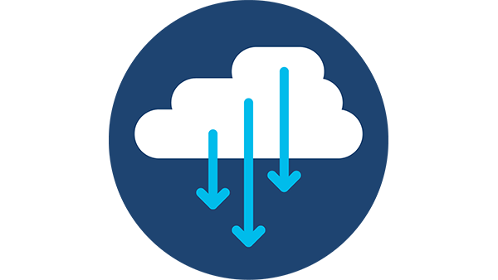

## Managed services data centers

These data centers are managed by a third party (or a managed services provider) on behalf of a company. The company leases the equipment and infrastructure instead of buying it.

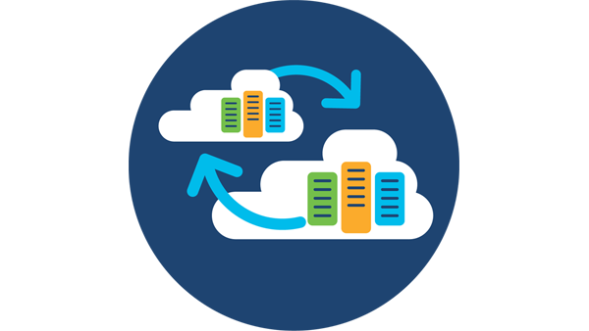

## Colocation data centers

In colocation ("colo") data centers, a company rents space within a data center owned by others and located off company premises. The colocation data center hosts the infrastructure: building, cooling, bandwidth, security, etc., while the company provides and manages the components, including servers, storage, and firewalls.

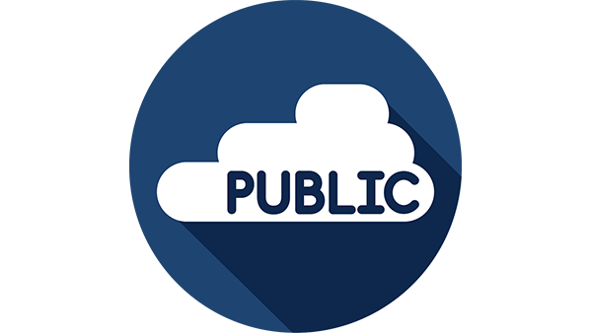

## Cloud data centers

In this off-premises form of data center, data and applications are hosted by a cloud services provider such as Amazon Web Services (AWS), Microsoft (Azure), or IBM Cloud or other public cloud provider.

# Literature Review

Data Center infrastructure refers to the core physical or hardware-based resources and components – including all IT infrastructure devices, equipment and technologies – that comprise a data center. It is modeled and identified in a design plan that includes a complete listing of necessary infrastructure components used to create a data center. (Techopedia, 2021)

# **History of Data Center**

**1946**

Probably the first data center was built in the USA in 1946, and it was called ENIAC (Electronic Numerical Integrator and Computer). The American army used it for storing defense codes. This computer was still not using transistors. Instead, it had almost 18 thousand vacuum tubes, 7200 crystal diodes and 10000 capacitors. The thing was huge – 167.2 square meters (1 800 square feet)!

**1960’s**

During the 60s, the vacuum tubes were replaced with transistors. The company that put the strongest effort at that time was IBM, with their System series of mainframes. During that time, the virtualization technology was invented, and the mainframes started to multitask.

In 1964, the first supercomputer got introduced. It was the CDC 6600, with the performance of 1 MFlops and peak at 3 MFlops.

**1970’s**

The 70’s started exciting with the introduction of Intel’s 4004 processor (1971). It was the first general-purpose programmable processor that became the “brain” of different customized software.

Two years later, Xerox Alto got into the market and presented the first graphical UI. This computer was way ahead of its time and it even came with a 3-button mouse.

In 1977, the Chase Manhattan Bank applied the first LAN – ARCnet. It supported up to 255 computers and a data rate of 2.5 Mbps.

Just a year later, the American multinational software company SunGard established the first commercial disaster recovery.

**1980’s**

The massive and expensive mainframes were dying. They were replaced with cheaper and easier to maintain PCs.

The American computer manufacturer Sun Microsystems created the network file system protocol. With it, the client computers were able to access files over the network in a similar way to accessing internal storage.

**1990’s**

The 90’s was a time of the .COM boom. The internet usage was rapidly increasing, and so was the demand for better connectivity. Due to that demand, data centers also gained popularity. There were new and larger centers emerging. The service model of the data centers became common for many companies.

**2000-2018**

At the beginning of the period, power efficiency was beginning to cause maintenance issues. The current generation of data centers was consuming too much power. This started a trend to improve the efficiency, build better cooling systems and to reduce the consumption.

In 2002, Amazon started their web services AWS, which include cloud computing, storage and more. Ten years later, 38% of the business was already in the cloud.

Today, the data center is driving to a new model (client-server) based on subscription. Companies choose this model to reduce their costs. They don’t need to purchase expensive hardware and constantly upgrade it. Instead, they use cloud services, where a third party is responsible for the hardware resources and often for the IT support as well.

The future consists of low-power, long-lasting client devices that connect to the cloud (data centers) where all of the processing is done.

# Data center standards

Data centers and their contents must adhere to a wide range of standards, ranging from local building codes to guidelines from the American Society of Heating, Refrigerating and Air-Conditioning Experts (ASHRAE) on cooling to a number of requirements placed on the IT equipment. There are also a number of standards related to the structured cabling infrastructure that serves as the platform for IT equipment in the data center.

Common Scope monitors data center trends and participates in standards organizations to help data center operators stay ahead of the industry. Given the relentless growth in data traffic and the need to provide high-bandwidth, low-latency connections, there has been a tremendous amount of activity within the standards bodies to define higher speeds. It is important to keep up with the latest developments to ensure the cabling infrastructure can support these higher speeds with minimal disruption.

Data Center Standards include:

* **Uptime Institute's Tier Standard**
* **ANSI/BICSI 002-2014**
* **ANSI/TIA 942-A 2014**

### **EN 50600: an International Standard**

### **Regulatory Standards**

### **Operational Standards**

(“Datacenterknowledge,”2021)

# Data center Tiers

Data center tiers are a system used to describe specific kinds of data center infrastructure in a consistent way. Tier 1 is the simplest infrastructure, while Tier 4 is the most complex and has the most redundant components. Each tier includes the required components of all the tiers below it.

## 1 Tier

A Tier I data center is the basic capacity level with infrastructure to support information technology for an office setting and beyond. The requirements for a Tier I facility include:

* An uninterruptible power supply (UPS) for power sags, outages, and spikes.
* An area for IT systems.
* Dedicated cooling equipment that runs outside office hours.
* An engine generator for power outages.

Tier I protects against disruptions from human error, but not unexpected failure or outage. Redundant equipment includes chillers, pumps, UPS modules, and engine generators. The facility will have to shut down completely for preventive maintenance and repairs, and failure to do so increases the risk of unplanned disruptions and severe consequences from system failure.

# 2 Tier

Tier II facilities cover redundant capacity components for power and cooling that provide better maintenance opportunities and safety against disruptions. These components include:

* Engine generators.
* Energy storage.
* Chillers.
* Cooling units.
* UPS modules.
* Pumps.
* Heat rejection equipment.
* Fuel tanks.
* Fuel cells.

The distribution path of Tier II serves a critical environment, and the components can be removed without shutting it down. Like a Tier I facility, unexpected shutdown of a Tier II data center will affect the system.

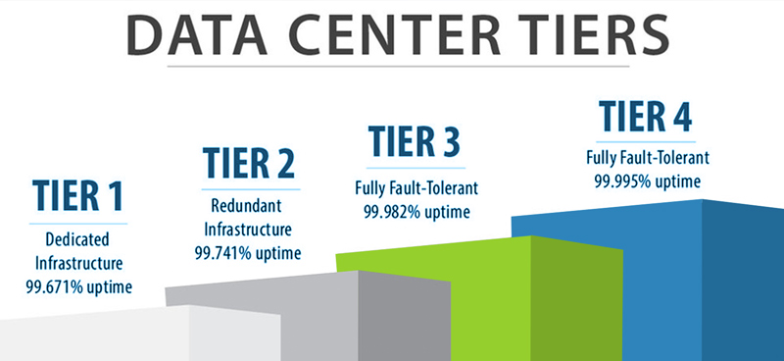

## 3 Tier

A Tier III data center is concurrently maintainable with redundant components as a key differentiator, with redundant distribution paths to serve the critical environment. Unlike Tier I and Tier II, these facilities require no shutdowns when equipment needs maintenance or replacement. The components of Tier III are added to Tier II components so that any part can be shut down without impacting IT operation.

# Datacenter infrastructure design

Datacenter infrastructure design is vital where several aspects need to be cautiously well-thought-out such as performance, resiliency, scalability and flexibility in fast deploying and supporting new services. (Sawehli & Wei, 2018)

# Types of data center infrastructure

* Server infrastructure

Such as Dell, PHP, IBM servers.

* Storage infrastructure

Such as storage area network (SAN) or backup/tape storage, Hardisks.

* Network infrastructure

Such as routers or switches, Rocks , firewall, Physical server racks/chassis ,Cables

(Geng, 2014)

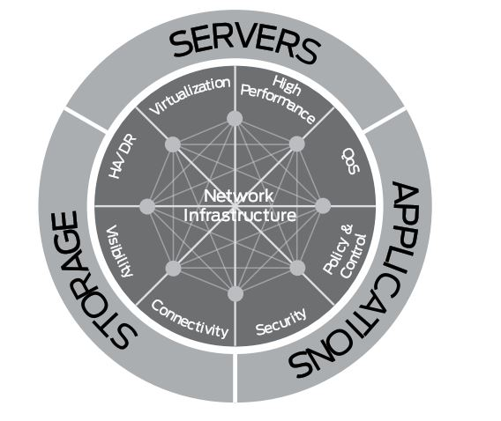

# A data center infrastructure also include

* biometric security system
* Data center management software/applications
* Power and cooling devices, such as air conditioners or generators
* Cables
* Internet backbone

# Data Center Physical Infrastructure

The physical infrastructure in the data center is the base of the pyramid upon which all computing, network and storage resources rest, and upon which all business critical applications rely. If the physical infrastructure is not ready to handle server consolidation, for example, this could create serious problems. It would be like trying to redo the foundation after the house is built. Building the right physical infrastructure is not a one-time undertaking and it means building something that is flexible and can adapt as the business requirements change, and as the application mix changes. Those dynamics are consistently changing. Whether it's a multi-megawatt data center, a small LAN room, or even a small wiring closet with a VoIP switch deployment, equipment has to operate successfully and depends on the power, cooling, and physical infrastructure that supports it. That is what is meant by Network-Critical Physical Infrastructure (NCPI). It is the foundation one layer below the physical IT equipment like the servers, or switches. Course Credits: * This course has been approved by Institute of Electrical and Electronics Engineers (IEEE) for one (1) PDH * This course is recognized for continuing education credit from IFMA for CFM/FMP Maintenance Points.  
* Recognize the importance of having a solid Network-Critical Physical Infrastructure (NCPI) * Define NCPI * Describe the seven elements of NCPI * Identify the challenges associated with the seven NCPI elements * Discuss best practices associated with the seven NCPI elements

# Data center network Infrastructure

The data center network design is based on a proven layered approach, which has been tested and Improved over the past several years in some of the largest data center implementations in the world. The layered approach is the basic foundation of the data center design that seeks to improve scalability, performance, flexibility, resiliency, and maintenance. (Nguyen & Hoàng, 2020)

Data center's design is based on a network of computing and storage resources that enable the delivery of shared applications and data. The key components of a data center design include routers, switches, firewalls, storage systems, servers, and application-delivery controllers. . (Nguyen & Hoàng, 2020)

Network Devices in data center By following OSI or TCP/IP protocol stack model, it is quite easy to understand the function of each type of network hardware device in a DC topology.

Normally data is generated, encoded and compress in layer 6 and 7, authentication and authorization to access a server is perform in layer 5, in layer 4 data is for segmentation divide data into segments and then send those segments across multiple networks in layer 3 in form of packets. When the packets arrive at the destined network, packets are transmitted between devices inside a LAN in layer 2 after forming into frames then go across the cable as BITs . (Nguyen & Hoàng)

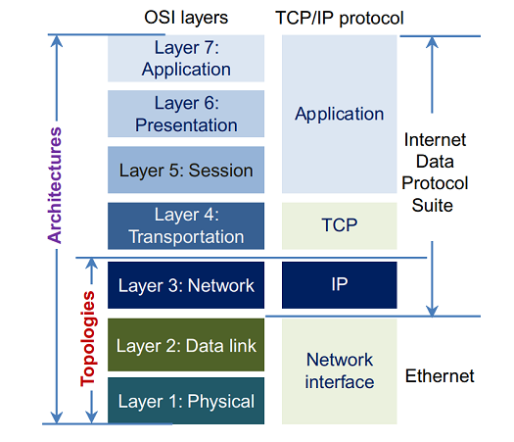

## Severs

Server is where the critical data inside a DC is accessed, managed, and processed.

They provide the computing power needed to execute user applications, operating systems,

file transfer services, computational services for large scientific workflows, and

Communications. (Nguyen & Hoàng, 2020)

Type of Data Datacenter Servers

* Rack mounted/ rack servers,
* Blade servers

## Rack mounted:

A rack-mounted server or standard racked server or simply a rack server is the

Standard server box that can be fit into a standardized rack. (Nguyen & Hoàng, 2020)

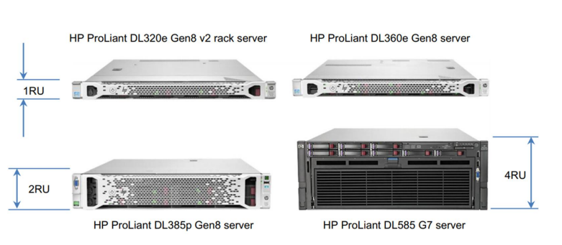

## Blade servers:

Blade servers on the other hand have the vertical mounting arrangement approach on the majority when compared with rack servers. They are more compact and have a higher density therefore more suitable and very efficient for large scale or warehouse type data centers n the downside, due to high physical density of the internal components

and insufficient space for the air flow, cooling is difficult and more expensive in blade

Servers compared to rack servers. . (Nguyen & Hoàng, 2020)

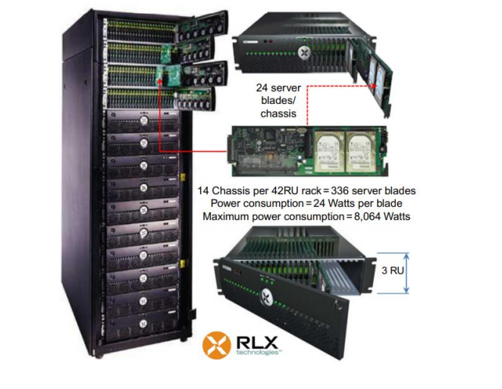

## Storage system

With the never ending and ever rising amount of data that need to be stored, storage Demand has the expansion of 50-70% per year. Currently Hard Disk Drives (HDD) and Solid State Drives (SSD) are two prominent storage hardware components inside a DC With HDD is the most popular and cost-effective solution. When it comes to business data Storage systems, the major options are direct-attached storage (DAS), network-attached Storage (NAS) and storage area networks (SANs).(Nguyen & Hoàng, 2020)

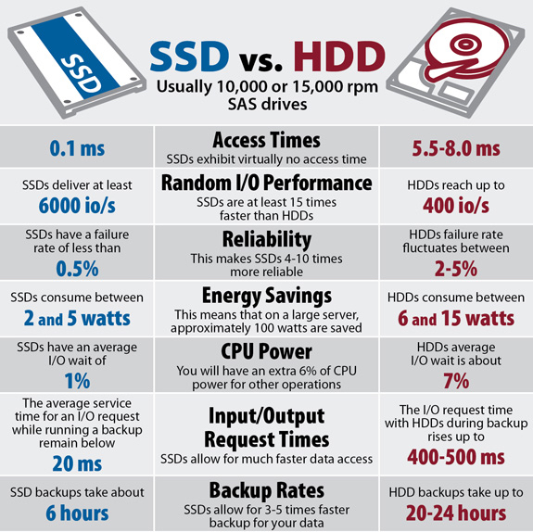

## Router

A router is the first line into a network and to resolve the layer 3 communication issues, a network router is required. The router joins different types of networks (LAN/WAN). The way a router directs network traffic is based on packet IPs (logical addresses) rather than MAC (physical addresses). It reads all incoming data packet logical addresses and then based on its own routing table to forward these incoming data packets to their destinations. Routers are like small computers that are designed and configured specifically for routing purpose. A typical router has a CPU, RAM, I/O interfaces, and an operating system (OS). For example, Cisco routers have an OS named the Internetwork Operating System (IOS) [20, 23]. These hardware and software are the two basic components of a router: the forwarding engine and routing engine. (Nguyen & Hoàng, 2020)

The **Spanning Tree Protocol** (**STP**) is a network protocol that builds a loop-free logical topology for Ethernet networks.(wikipdia,n.d.)

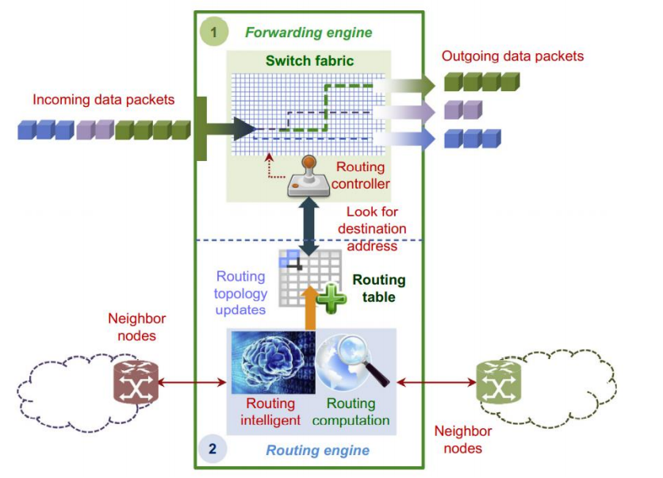

## Classification of Router: interior, exterior, and border

### Interior:

Interior router connects many autonomous LANs across location despite the geography.

### Exterior

Exterior connect to the Internet as a backbone.

### Border or gateway

Border or gateway router is the network device that connects interior and exterior routers. Interior or border (gateway) routers are those to be in a data center. (Nguyen & Hoàng, 2020)

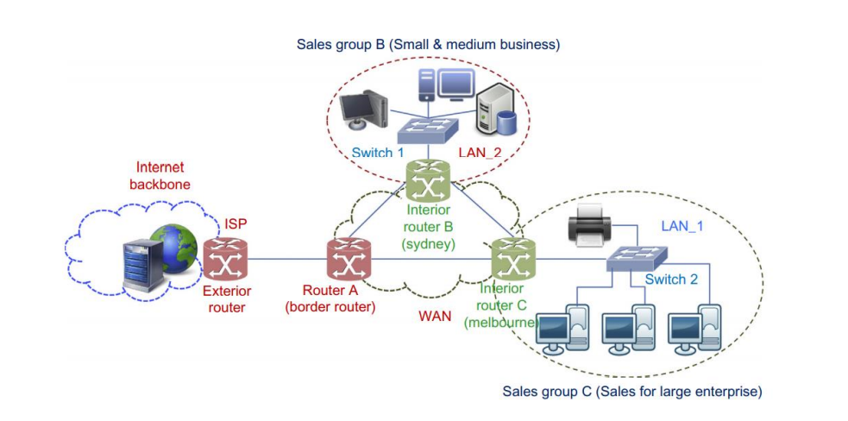

## Switch

Switch is a component that allow layer 2 communication and forms LAN/WAN. The switch joins all computer devices together to share information and resources. In a fully switched network, switching allows the network to maintain full-duplex Ethernet. Before that, data could be transmitted in only one direction at a time or half-duplex. With a fully switched network, each node communicates only with the switch, not directly with other nodes. Information can travel from devices to switch and from switch to devices simultaneously provided that the switches can permit data to be sent and received concurrently .The switch handle data transfer by dealing with MAC or physical address inside the NIC (Network Interface Card) of the device it connected to (Figure 11). When a device is connected to the switch, the switch will remember the MAC address of that device and which port did the device use to connect and put it in the MAC table. Data travel in frame through the switch contain the MAC address of both source and destination; the switch compares the MAC address of the destination with the MAC table and then forward the frame to the port that matches. (Nguyen & Hoàng, 2020)

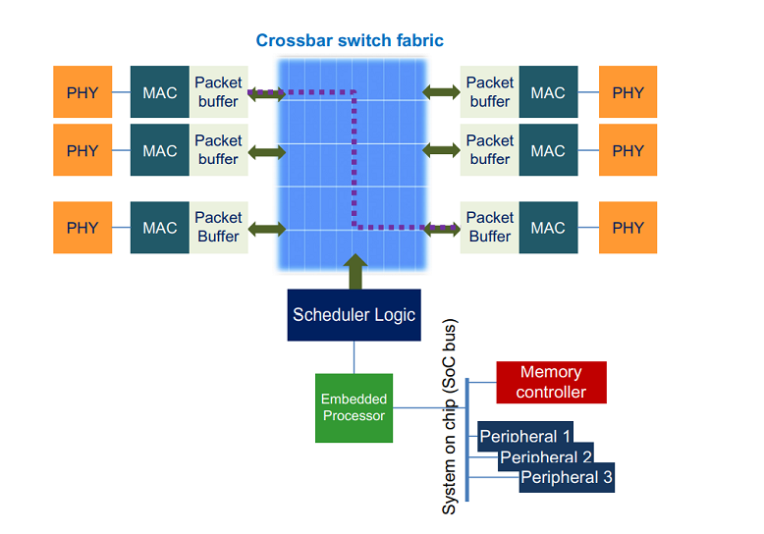

A typical switch functional block diagram

## Firewall

A firewall is a network security device that monitors incoming and outgoing network traffic and decides whether to allow or block specific traffic based on a defined set of security rules. It acts like a barrier between your LAN and incoming traffic from external sources (such as the internet) in order to block malicious traffic like viruses and hackers. A firewall can either be hardware, software, or both [25,26].Physical placement of firewall devices in the data center network infrastructure is one of the most important decisions network and security architects have to make(Nguyen & Hoàng, 2020)

. There are primarily two options for firewall placement:

* Physically inline (in the traffic path between the core and the server).
* Logically in-line with one arm of the firewall physically connected to the network Core

## Load Balancer

The load balancer helps servers transfer data efficiently, optimizes application delivery resources and prevents server overloads. If a server is out of order, the load balancer redirects traffic to the remaining available servers, load balancers are typically deployed in either inline or one-arm. (Nguyen & Hoàng, 2020)

## Cable and raise floor

Network cables are used to connect and transfer data and information between computers, routers, switches and storage area networks. These cables are essentially the carrier or media through which data flows. Copper and optic fibers are two common solutions for cable in data center. While optic fiber cable is better than copper cable in many aspects, due to high initial and operational cost, most data center is using a mix of copper and fiber optic cable. (Nguyen & Hoàng, 2020)

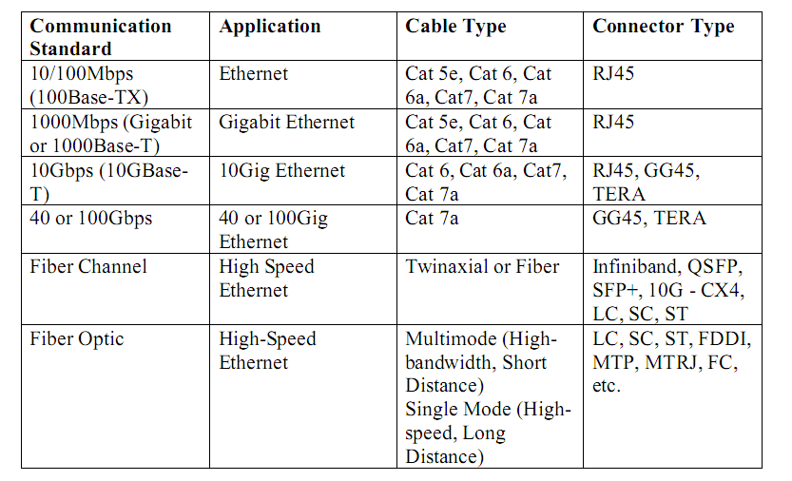

Overview of Data Center Cabling Types

Raised floor ensures high load support, easy to access, maintenance of underfloor equipment, cleaning, and safety. Flexible module for a cold air distribution system for cooling IT equipment, to tracks, conduits, or supports for data cabling, a location for power cabling, a copper ground grid for grounding of equipment, a location to run chilled water or other utility piping. (Nguyen & Hoàng, 2020)

* A cold air distribution system for cooling IT equipment
* Tracks, conduits, or supports for data cabling
* A location for power cabling
* A copper ground grid for grounding of equipment
* A location to run chilled water or other utility piping

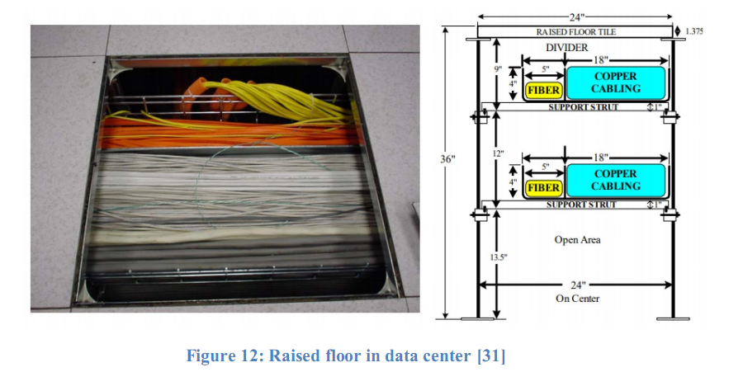

# DATA CENTER NETWORK TOPOLOGIES:

Data center network layer Base on the OSI or TCP/IP model, the data center network (DCN) is a layer 2 and layer 3 network since it operates between these two layers . The DCN topology will be designed to effectively connect all network components within a data center (switches, routers, load balancers, firewalls, storage component…). The impact of the network topology inside a DC can be seen in the data traffic performance, which includes data packet routing, DCN reliability, scalability, throughput, latency, and flexibility . (Nguyen & Hoàng, 2020)

## Data center network layer

Base on the OSI or TCP/IP model, the data center network (DCN) is a layer 2 and layer 3 network since it operates between these two layers (Figure7, Figure 13). The DCN topology will be designed to effectively connect all network components within a data center (switches, routers, load balancers, firewalls, storage component…). The impact of the network topology inside a DC can be seen in the data traffic performance, which includes data packet routing, DCN reliability, scalability, throughput, latency, and flexibility. (Nguyen & Hoàng, 2020)

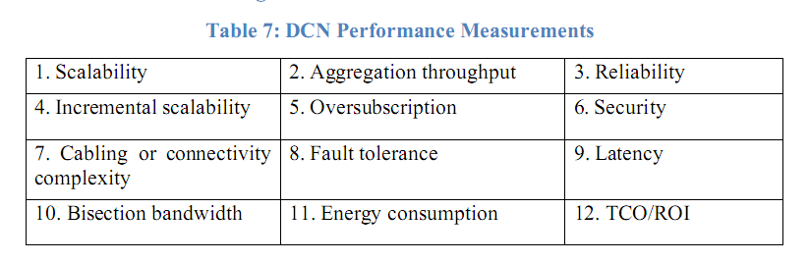

## Data Center Network Topology

The tree-based topology is one of most widely adopted solutions for DCN. It normally consists of three tiers: core, aggregation (or distribution) and edge (or access) (Figure 000). Each tier corresponds to either layer 2 or 3 or both layers of the OSI or TCP/IP model. The core layer provides connectivity where other devices connect (Figure 13). The aggregation layer is the layer 3 and layer 2 boundary in the DCN, it aggregates connections and traffic flows from multiple access layer switches to provide connectivity to the LAN core or WAN edge layer switches [32]. In common designs, the aggregation layer provides value-added services, such as server load balancing, firewalling, and SSL offloading to the servers across the access layer switches . In a small or medium size data center network, the core and aggregation may collapse into one single layer that leverages the virtual device contexts capability for consolidation (Figure 15) [35]. Access layer is the lowest of the three layers of the architecture, where all servers physically attach to the network(Nguyen & Hoàng, 2020). A tree-based (common three levels or tiers) topology has the following advantages:

✓ Scalability

✓ Accessibility for troubleshooting

✓ Easier to deploy

✓ Cost effective

✓ Better for local traffic

✓ Lower latency

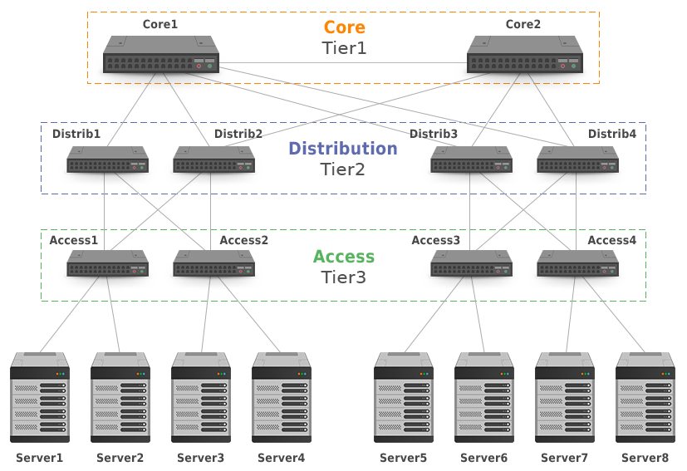

## Network configuration topology

## Top of Rack (ToR)

ToR is one of the popular tree-based DCN design. The servers connect to one or two Ethernet access switches installed on the rack at access level. Of course, the switches does not have to literally mounted on the top to connect to all severs inside the rack. Other switch locations could be bottom of the rack or middle of rack, however top of the rack is most common due to easier accessibility and cleaner cable management. All the access switches are connected to the aggregation switch. (Nguyen & Hoàng, 2020)

Only a small amount of cables are needed to run from server rack to aggregation rack; but in big data center, the number of rack will prove to become troublesome. According to , the advantages and disadvantages of TOR are as follow:

## Advantages:

• Flexible and modular setup using per rack solution

• Racks can be easily relocated or upgraded or changed

• Elimination of long running bulk copper cables

• Reduction of copper cable expense

• Ready for future optical fiber cable infrastructure

• Contain copper cables within a rack

• Less cold airflow resistance and lowering of raised floor height

## Disadvantages:

• Logical VLAN capacity bottleneck

• More L2 switches to manage

• Potential physical port scalability issues at aggregation switch level

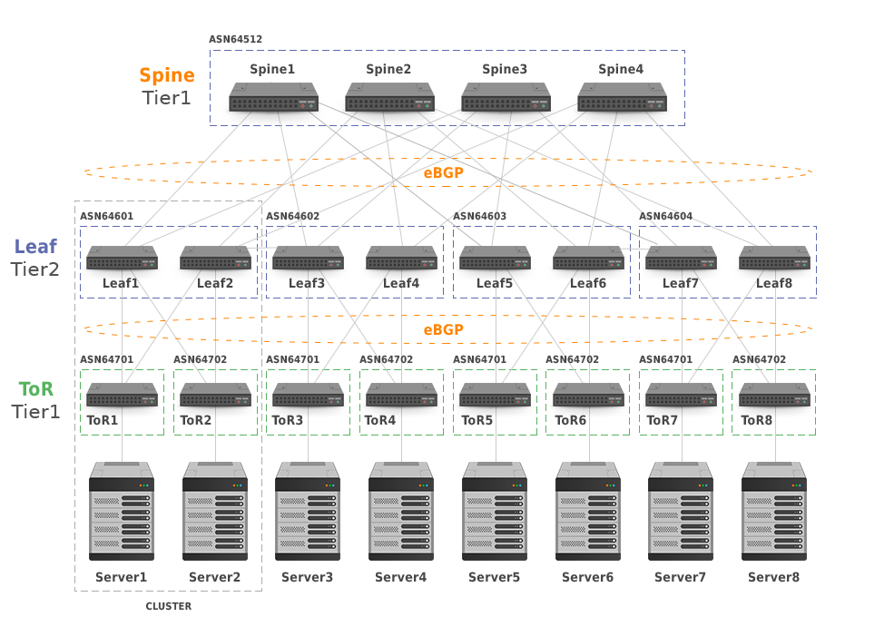

## End of Row (EoR):

For a DC that possesses a high number of racks to manage and wants to use a tree base topology, one of alternative is to adopt an end of row (EoR) solution (Figure 17) which connect all severs in a row of racks to a switch at access level. It is not necessary that the location of the switch rack be at the end of row. It can be at any position of the row as long as it is within the row. (Nguyen & Hoàng, 2020)

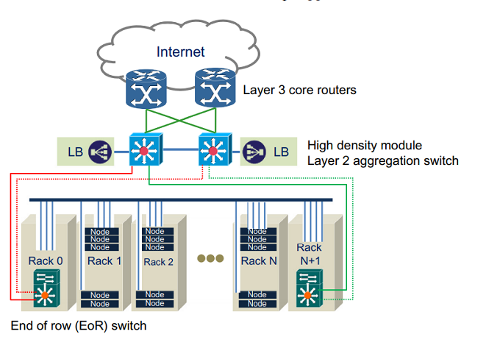

## Middle of ROW (MoR) :

One of the popular solutions is to place switch racks in the middle of the row (MoR) (Figure 18). The use of extremely long copper cable can be avoided if the rack row is quite long with the use of MoR. The EoR or MoR solution provides the following advantages that are almost opposite to the ToR solution; the ToR’s disadvantages become the EoR’s advantages and vice versa. (Nguyen & Hoàng, 2020)

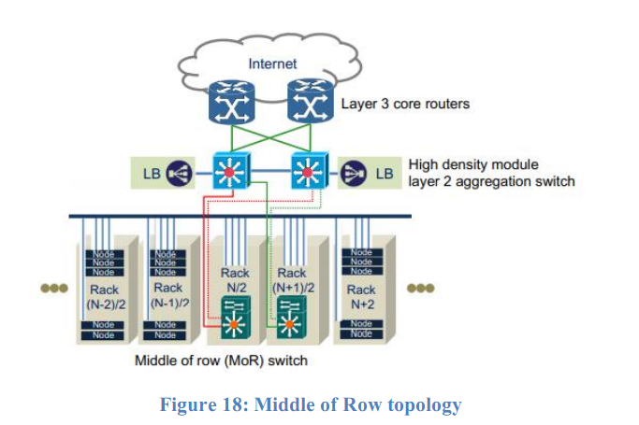

## Advantage of EoR and MoR:

• Fewer switches to manage

• More reliable DCN

• Reduction in switch capex

• Lower maintenance cost

• Fewer aggregation ports

• Fewer SFP instances in layer 2 domain

Disadvantages:

• More and longer copper cables run

• Less flexible than ToR solution with an incremental investment approach

• Future challenges for optical fiber cable solution

• Higher raised floor to accommodate bulk of running copper cables

# Problem Description

# In Next draft Solution Description

# In Next draft Implementation Description Possible Extensions

# Summary and Conclusions

# References and Bibliography

Data center. (2004, April 6). Wikipedia, the free encyclopedia. Retrieved January 19, 2021, from <https://en.wikipedia.org/wiki/Data_center>

Ports, D. R., Li, J., Liu, V., Sharma, N. K., & Krishnamurthy, A. (2015). Designing distributed systems using approximate synchrony in data center networks. In *12th {USENIX} Symposium on Networked Systems Design and Implementation ({NSDI} 15)* (pp. 43-57).

Roy, A., Zeng, H., Bagga, J., Porter, G., & Snoeren, A. C. (2015). Inside the social network's (Datacenter) network. *ACM SIGCOMM Computer Communication Review*, *45*(4), 123-137. <https://doi.org/10.1145/2829988.2787472>

What is a data center? (n.d.). Cisco. <https://www.cisco.com/c/en/us/solutions/data-center-virtualization/what-is-a-data-center.html>

DATA CENTRE | meaning in the Cambridge English dictionary. (n.d.). Cambridge Dictionary | English Dictionary, Translations & Thesaurus. <https://dictionary.cambridge.org/dictionary/english/data-centre>

Geng, H. (2014). Data center handbook. John Wiley & Sons. Sarkar, C. (2010). Data Center Network Design. *IIT Bombay, Bombay*.

Nguyen, X. T., & Hoàng, N. V. (2020). Data Center Network. BACHELOR THESIS Data Center Infrastructure: Network Design Concept.

https://uptimeinstitute.com/tiers

Data Center Tiers Security Service

See discussions, stats, and author profiles for this publication at:

https://www.researchgate.net/publication/260402714

# Appendix A List of Files

# Appendix B User Manual

# Appendix C Source Listing